报告题目：Coexisting Electric and Magnetic Order in Inorganic-Organic Hybrids

报告人：Prof. Thomas T. M. Palstra，Zernike Institute for Advanced Materials，University of Groningen, The Netherlands

时间地点：11月28日（星期三），2:30pm，物理系三楼报告厅

报告摘要：Multiferroics are based on simultaneous magnetic and polar order and have been widely studied in the transition metal oxides. They allow coupling of magnetic order with electric fields. Several mechanisms have been established that support such coexisting orders. I will discuss organic-inorganic hybrid systems, in which the inorganic component is responsible for the magnetic order-disorder and the organic component for the electric order-disorder. Such hybrid materials can be synthesized in bulk and thin film form and allow the design of various coexisting properties.

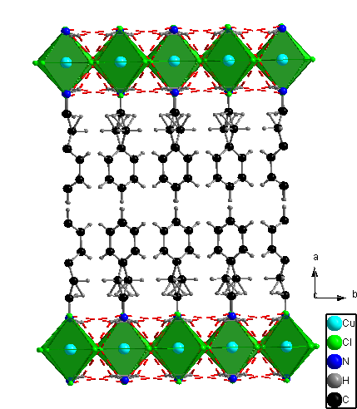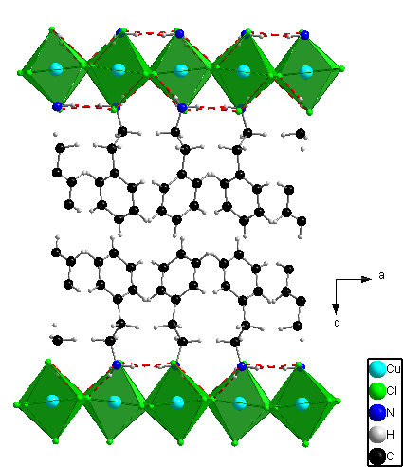

报告人简介: Prof. Thomas Palstra holds a chair in Solid State Chemistry and has a leading research group in electric conduction, magnetism, superconductivity and ferroelectrics. His present scientific interests include crystal structure-property relationships of transition metal oxides, organic conductors and organic-inorganic hybrid materials. He has coauthored 190 manuscripts which were cited 13500 times, resulting in a Hirsch-index of 57. He was elected in 2010 member of the Royal Netherlands Academy of Arts and Sciences, KNAW. He has been the dean of the Faculty of Mathematics and Physical Sciences (2008-2009), and is presently director of the Zernike Institute for Advanced Materials. During his tenure as director, the Zernike Institute increased its ranking worldwide from no.9 to no.4 in Materials Research Institutes according to the Times Higher Education index. This is the highest ranked institute in Europe.